Family Maths Events
Are you looking for a new way to engage your school community? Why not ditch the bath bombs on Mother’s Day and make marvellous mathematical memories instead? Use the Paper Planes challenge to run a flying competition. Be inspired by the Symmetry Challenge to create a tapestry of symmetrical designs at a Father’s Day breakfast.

Research has shown that parents and carers can have a big impact on their children’s attitudes and beliefs towards maths. An event such as a Family Maths Night or a Maths Morning Tea involves families coming to your school for 45 minutes or more to engage in fun and open-ended maths challenges and activities. These events can be a great way for schools to make a positive connection with families. A night of hands-on, collaborative challenges can present maths in a different light to what parents and carers may remember from their own experience.

The Victorian Maths Challenge can be used as the basis for family maths events. The variety of problems and investigations promote maths as a creative, enjoyable and important subject. Each challenge showcases how mathematical skills, approaches and understandings are used to solve problems in fields such as design, construction, marine engineering, navigation and aviation. The challenges can spark conversations about how maths impacts our daily lives, how it is used across a wide range of professionals fields and the crucial role it will play in solving future problems. The videos introducing each challenge showcase how STEM disciplines are linked to current professional fields.

Parent communities of schools that have hosted a Victorian Maths Challenge family maths night or morning tea describe the experience as “very positive”. They saw the challenges as “fun, challenging and engaging.” Participating students were enthusiastic and engaged. They shared their own ideas for challenges. Teachers responded positively to the quality of the challenges and their usefulness as tools for fostering engagement, and their capacity to engender positive attitudes towards mathematics.

How to host a successful Family Maths Event
Family maths events can range from a forty-five minute Maths Morning Tea to multiple Family Maths Nights over a term. The important thing is that families get a chance to engage with some fun maths concepts.

Like so many things, Family Maths Events work best if there is a bit of planning beforehand. Firstly, lock in support from other teachers and/or student volunteers. You will want approximately as many staff members as challenges you are running. Decide when and where you want to run it. A large open space like a gym or library usually works well. Secondly, choose which challenges you want to use for your event. Familiarise yourself with the Victorian Maths Challenge, including how to submit entries. Thirdly, logistics! Organise promotion, catering and materials. We have provided some downloadable tools and templates below, for those who find such things useful.

During your event you should expect some joyful chaos. Staff and students just need to be on hand to provide support and ask prompting questions.
Depending on the event, it is worth considering:
- providing food, coffee and tea
- if you want families to move between challenges in a specific order, or as they wish
- providing a ‘Family Passport’ so that people can tick off challenges they have tried
- if you want to have a formal welcome, or if you want to just let people join in as they arrive
- if you want to have a formal end to the event, with some discussion about the maths explored during the event
- asking for feedback through an evaluation survey

Advice for secondary teachers
Secondary school parents have a tendency to ‘scale back’ their involvement in their child’s maths, often due to their own perceived mathematical shortcomings. A Victorian Maths Challenge event gives schools an opportunity to re-establish the importance of parent interest and involvement in their child’s mathematics. It might be easier to start by targeting Year 7 students and their families.

Tools and templates in this pack:
- Family Maths Event checklist
- Challenge material lists and prompting questions
- Information for families text
- Event running sheet template
- Family Passport
- Newsletter story text

Family Maths Event – checklist
Before
- Decide on which challenges to make available

- Identify participating staff and volunteer students

- Set date and time

- Decide if catering, what food and beverages will be available
Caterer:
- Decide on venue:
- Promote to families
  - Newsletter
  - Facebook
  - Other
- Acquire materials
  - See materials list for each challenge
- Acquire food and beverages

On the day
- Set up challenges and registration table
- Assign staff and students to each challenge
  - See sample running sheet

Afterwards
- Write up newsletter story

You can use this passport to record all the challenges your family tried!
Get a stamp from every challenge station.

Eureka! | Paper Planes
Right Direction | Symmetry
Titanic | Traveller

[EXAMPLE information for parents and carers]
<Roary P-12> is holding a <Family Maths Night> to take part in the Victorian Maths Challenge.
Families are warmly invited to a night of open-ended maths challenges and puzzles.
<Date / Time / Location> <Food will be provided.>
Please bring:
- yourselves and your family members
- a willingness to embrace some fun maths
- a phone or tablet to submit your entries directly to the Victorian Maths Challenge
The Victorian Maths Challenge is a fun and engaging resource to give you an opportunity to explore everyday maths challenges with your family. The Victorian Maths Challenge is a great way for you, your family and friends to explore and solve problems!
- Take on as few or as many challenges as you like.
- Work together to find your own solutions.
- Capture what you discover with a video, photo, diagram or story. You can even share your findings on the VMC website!

You can make a difference, get involved, join the fun!
Parents and carers have a big impact on their children’s understanding and attitude towards maths. By providing learning opportunities and support at home, you can help encourage maths learning from an early age right through high school. Taking part in the Victorian Maths Challenge is a great opportunity to show your interest and share a love of learning with your child.

Please register your interest by returning the information below:

I ___________________ will attend the <Family Maths Night> on <date and time>
Please circle the year level/s your child/children are enrolled in
P 1 2 3 4 5 6 7 8 9 10
If you would like more information on the Victorian Maths Challenge <information session/family night/morning tea> please contact ______________________________

Check out the Victorian Maths Challenge by visiting: http://vmc.global2.vic.edu.au/

[EXAMPLE newsletter story]
The Families at _________________________________ taking on the Victorian Maths Challenge!
At <Roary P-12’s> recent <family maths night / maths morning tea> families took on <several maths challenges> where they <built towers / flew planes / made gorgeous designs>. They did a wonderful job, and it was great to hear so many exciting conversations about the maths in the tasks!
Well done to all of our up-and-coming mathematicians and engineers. Take a look at some of the photos from the (morning/day/night) and marvel in the wonders of our mathematically minded community.
Insert photos from the event | Insert photos from the event | Insert photos from the event
Insert photos from the event | Insert photos from the event | Insert photos from the event

If you would like to take part in the Victorian Maths Challenge, please visit http://vmc.global2.vic.edu.au/. There are many great activities to do at home.
This is a great way to contribute to your child’s learning. You can use the challenge to discuss how your family uses maths in the workplace and in everyday life.
For more information, please contact: <school staff member>

Family Maths night – Running sheet template
Time | Activity | Staff | Room | Notes
5:00pm | Set-up materials | All | All
5:30pm | Welcome and registration /  Explain how to submit to the VMC site | Alicia and Beyonce | Gym
5:45-6:45 pm | Station 1 – Eureka | Nivea | Gym north
 | Station 2 – Paper Planes | Jennifer | Oval
 | Station 3 – Right Direction | Tamar | Gym south
 | Station 4 – Symmetry | Vivian | Classroom A
 | Station 5 – Titanic | Dylan | Oval
 | Station 6 – Traveller | Mariah | Gym south
 | Food available | Bronwyn and Scott | Canteen
6:45pm | Close
7:00pm | Pack down | All | All

Victorian Maths Challenge – Challenges, Materials and Prompting Questions

Eureka

The Challenge
Build the tallest free standing tower you can.
- Gather your construction team. You may want to involve a parent, grandparent, brother, sister, or family friend.
- Collect as much paper as you like (think about using old newspapers or junk-mail – no cardboard).
- Find some sticky tape, scissors and a tape measure if you want to measure how tall your finished tower is.
- Clear some space, take as much time as you like, and using the paper, sticky tape and scissors start building.
- Grab a camera to capture images or video of your tower.
- Reflect: what has building a tower taught you about the interaction between height, weight and stability?

Materials
- a device to view the challenge and submit entries
- sticky tape
- scissors
- lots of paper (not cardboard)
- tape measure or metre ruler
- 1 kg weights

Prompting Questions
- What are the tallest buildings you know?
- What shapes do you see in tall buildings?
- How are tall buildings supported?
- Are they wider at the top or bottom?
- What reinforcement can you see?
- Can you build with triangles to make your tower stronger?
- How can you construct a tower with the least amount of paper?

Keep going for an extra challenge
Now, try this: Using paper and sticky tape, make a bridge that crosses a gap of at least 30 centimetres. Will your bridge hold a shoe? Whose shoe could it hold?

Making the Most

The Challenge
Using 19 equal lengths, make as many different shapes as possible.
- Each person should gather 19 items which are straight and have the same length. These could be 19 toothpicks, matchsticks or pens. These 19 straight items will represent pieces of fence to build your plant enclosures. If you don’t have 19 for each person, team up.
- Find a flat surface to try out the different shape combinations.
- Build the maximum number of different shape enclosures using your 19 ‘fences’. They may not share any edges. That means there must be a gap between each enclosure. How many different enclosures can you make? Take a photo to share.
- Try again but this time build your enclosures so that they share common edges. Can you build 4, 5 or maybe even 6 different shaped enclosures?

Materials
- a device to view the challenge and submit entries
- many items which are straight and have the same length (e.g. Toothpicks, matchsticks, pens – need 19 per person)
- rulers

Prompting questions
- What patterns do you see in your garden at home and public gardens?
- What shapes would make the biggest number of enclosures? Think about the sides, corners and angles you might need to make.
- Measure the area and perimeter for various arrangements of the lengths and compare.
- Which shapes enclose the most area? Can you use parallelograms, rhombuses or kites to make more enclosures?

Keep going for an extra challenge
The shape below represents a farm house. Take 11 of your equal straight lengths and rearrange them into the following shape:
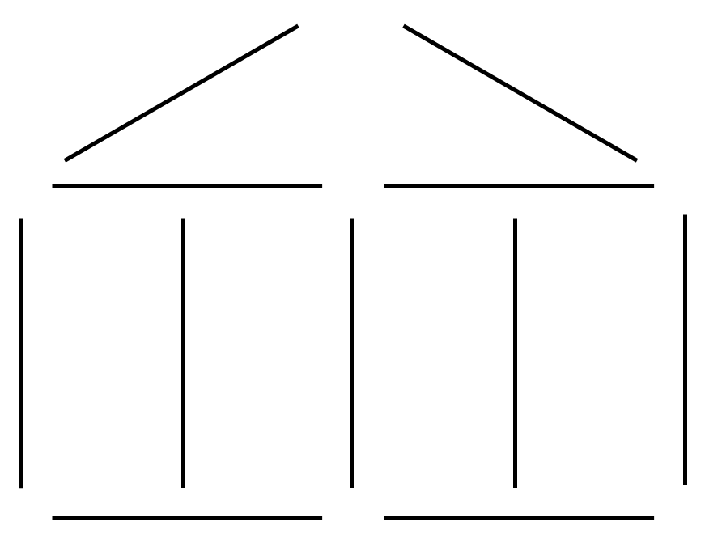

- By moving 2 lengths (pens/matchsticks/toothpicks), how many squares can you make? You may lay lengths on top of one another. Can you make 8, 10 or even 11 squares?
- By moving 4 lengths (pens/matchsticks/toothpicks), how many squares can you make? You may lay lengths on top of one another. Can you make 8, 10, 11 or even 15 squares?

Paper planes

The Challenge
Construct a squad of paper planes and estimate how far each plane will fly.
- Give each person in your family who is involved in this challenge a piece of A4 paper.
- Collect the following: a pair of scissors (for some plane designs), a ruler to help with folding (optional), a tape measure to measure flight distance (optional); a stopwatch to measure flight time (optional); and textas to decorate your designs (optional).
- Start designing and making paper planes. You can use this template and watch the video below to help you fold the plane. Alternatively you could make a different plane of your choice.
- Even though you are competing with other family members to see whose plane can fly the farthest, talk with each other about the positives, negatives and interesting points of each design to help make everyone’s plane better.
- Once everyone is satisfied with their plane, draw a table where each person records an estimation of how far their plane might fly and how long their plane might stay in the air. Think about units of measurement that could best be used for distance – would metres, centimetres or millimetres be best? Think about units of measurement that could best be used to record flight time. Do you think hours, minutes or seconds would be best?
- Launch your planes.
- Grab a camera to capture images or video of your planes.
- Reflect: who in your family made the plane that flew the furthest? Who in your family made the nearest estimations regarding their plane’s flight distance and time in the air?

Materials
- a device to view the challenge and submit entries
- scissors
- rulers/tape measure
- A4 paper (one sheet per person)
- stop watch
- textas or pencils
- optional template
- paper clips
- A3 paper
- newspaper
- thick paper

Prompting Questions
- What makes a plane fly?
- What is the best strategy to make the plane go further?
- What things are important in helping planes fly smoothly? Think about the balance of the wings, the way the air flows past each point of the plane, the shape of its nose, the angle you throw it at, the speed of take-off.
- Does a fast plane travel further than one that flies for a longer time?
- If you throw the same plane ten times, how far does it travel each time?
- How long would it take for one of your planes to fly to Ballarat if it kept on going?

PAPER PLANE INSTRUCTIONS + TEMPLATE
This instruction manual and template are intended to help you make your first paper plane. The use of this template is completely optional. It is designed to make folding your plane as simple as possible.
If you are confident folding your plane without the fold lines you could make a larger form of this plane by following the same steps (excluding Step 1) without using the cut out template provided.
STEPS:
- Cut along the dotted lines.

- Grab the top left corner and bring it to the centre line, folding along line #2. Repeat for the top right corner.

- Grab the new top left corner and bring it to the centre line again, folding along line #3. Repeat for the top right corner.

- Take the tip of the plane and fold it along line #4, placing it at the bottom of the intersection of your last fold.

- Fold the plane in half along line #5.
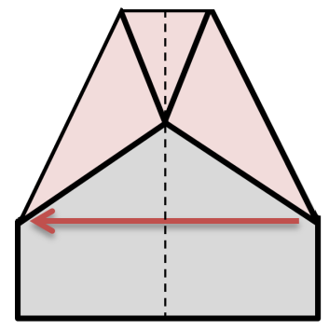
- Fold the plane in half again along line #6 so the diagonal side rests on the bottom line.

(1)
(1)
(6)
(6)
(5)
(4)
(3)
(3)
(2)
(2)
(1)
(1)

Keep going for an extra challenge
- Take a paper clip (or more than one if you want) and add it to different areas of your plane before flight. What changes does the paper clip cause?
- If you are lucky enough to have a piece of A3 paper, try making your plane with A3 paper. Does the A3 version fly further than the A4 version?
- Take another sheet of A4 paper and some tape. Try and make an extension for the wings on your plane and see if a plane with longer wings flies further.
- Try making your paper plane out of a different material. Consider using thicker paper or newspaper and comparing the flight of the planes.

Right Direction

The Challenge
Use verbal instructions to move a teammate from one place to another.
- Gather your team. You will need at least two people to play.
- Decide who will be giving instructions and who will be following these instructions. The person following the instructions can choose to be blindfolded or just close their eyes.
- Decide on a start and finish point. Pick points about 10 metres apart and mark them. The points can be in different rooms. You might not want to tell the blindfolded person where the finish point is.
- Clear some space. Be extremely careful and make sure the path you are going to use is safe.
- Give instructions to move your team from the start point to the finish point. You can only give two types of instructions, move forward (x) steps, and turn left/right or turn (x) degrees.
- Grab a camera to capture images or video of your instructions and how far your team travelled.
- Try to remember the instruction you received and walk backwards the same way you came. How close can you get to your starting point?
- Alternate between giving and receiving instructions after each game.
- Do it again! Make a harder course and give instructions using different units of measurement.
- Reflect: Which communication techniques/instructions were the most useful?

Materials
- a device to view the challenge and submit entries
- masking tape
- pens and paper
- blindfolds

Prompting Questions
- What words will make your instructions the most accurate? Be specific and consider what types of information will be most helpful such as compass points, left, right, how many metres.
- What types of things do you and your family rely on while using directions in the car?
- Give your instructions in centimetres and degrees, then give the same instructions using metres and left or right. How far from the end point does the person finish each time?

Keep going for an extra challenge
Draw a scale floorplan of your own house and write an algorithm for a robotic vacuum cleaner to make sure that it travels to each room and vacuums around the edges. What is the most efficient way to do this?

Rock scissors

The Challenge
Play ‘a first to 15 points game’ of ‘Rock-Scissors’ where points are given using the table below.
- Grab a piece of paper and a pen.
- Split into groups of two. If you have uneven numbers you can swap partners after a game to 15 points is finished. They don’t take long.
- The game works the same as ‘Rock, Paper, Scissors’ except you can only play rock or scissors. Instead of rock beating scissors, in this game, you receive points based on the table below. Don’t discuss the points table until after you have finished.
- After each round keep a tally of the score.
- Play until someone reaches 15 points.
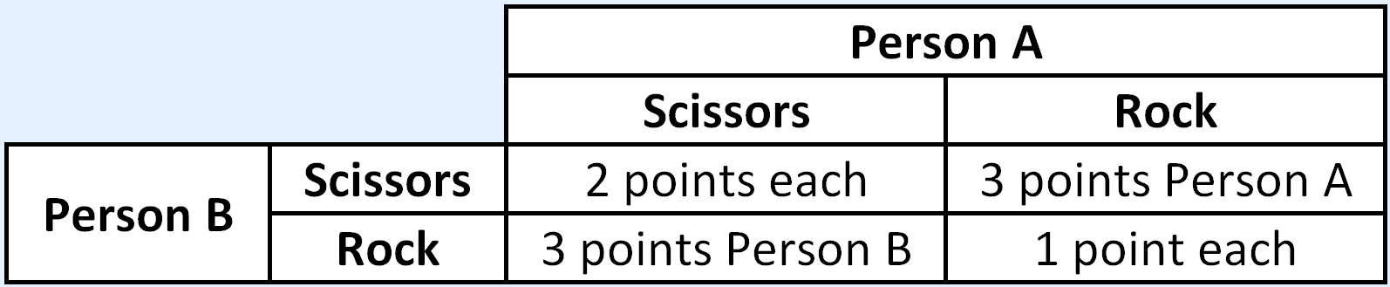
- If both players choose ‘Scissors’ then they each get two points.
- If both players choose ‘Rock’ each player gets one point.
- If one player chooses ‘Scissors’ and the other person chooses ‘Rock’, then the person who chose ‘Rock’ gets three points (and the person who chose ‘Scissors’ gets 0 points.
- Discuss: Was there any outcome that came up more often than the others? Have a look at the table again and discuss what the best strategy is to definitely beat your opponent. Is there a strategy that allows both players to win?
Materials
- a device to view the challenge and submit entries
- small pieces of paper (post-it note sized)
- pens
- dice

Prompting Questions
- How many options do you have to choose from?
- What probability would that make it?
- Think about what patterns you or your partner might use to get the best result.
- Watch your partner’s choices and try to predict what they will choose next.
- Calculate the probability of Rock or of Scissors for each turn. Keep note of how many times each person uses Rock or Scissors. Do their choices agree with the expected outcome? What could cause a value different from your prediction?

Keep going for an extra challenge
You find yourselves engaged in a three player laser tag duel. Read on!
1. Gather together a minimum of three people. Only three people can play at a time but you can rotate very quickly.
2. Grab three small pieces of paper, on the first piece write 33%, on the second write 67%, and 100% on the last.
3. Randomly distribute one of the pieces of paper to each person. This will be their ‘accuracy’. Make sure other players can see your piece of paper.
4. If you have 33% accuracy or 67% accuracy grab a 6-sided die each. If you don’t have dice you can use this website instead.
5. Stand in a triangle 2 metres apart.
6. On the count of three, point at another player.
7. If you have 100% accuracy, you hit the person you pointed at and they are out.
8. If you have 33% accuracy, roll a die. If you roll a 1 or a 2, you hit.
9. If you have 67% accuracy, roll a die. If you roll a 1, 2, 3 or a 4, you hit.
10. Because turns happen simultaneously you can both be hit and hit someone in the same round
11. Continue playing until one person remains standing or everybody is hit. If you are the only person who hasn’t been hit, you win the round.
Discuss: What do you think the best strategy is for each person? How about if the probability is changed to: 17%; 50%; and 100% – would you change your strategy?

Symmetry

The Challenge
Create a design using everyday objects.
- Gather your design team. You may want to involve a parent, a grandparent, brother, sister or family friend.
- Over a one hour period, keep track of everything you touch (excluding items you are currently wearing or have consumed!)
- At the end of the hour, collect all these objects in a space for sorting and designing. If you’ve amassed more than 50 items as a team, you can return the objects you’re less keen on.
- Arrange objects in three groups based on their attributes: the first collection having two or more of the same object, the second collection having 2 or more similar objects, and the third collection having many different objects. This classifying activity will help you to organise your objects depending on symmetry or the design attributes of shape, texture, colour or measurement.
- Using the same objects in the first collection, place them next to one another in different directions – experimenting with the lines of symmetry and creating different symmetrical patterns.
- For the similar objects in the second collection, create shapes like polygons and match each object’s design attributes where possible. For example, make a hexagon using 5 pens, with each nib facing in towards the centre, or make a rectangle with two mobiles placed top-to-top, faced-upwards.
- Finally, using the different objects in the third collection, place them around the other shapes and patterns, based on their unique design attributes. For example, you may like to place them at equal distances from one another (measurement) or in a gradient rainbow from left to right (colour).
- Grab a camera to capture your fantastic design – unique to you and your family’s life.

Materials
- a device to view the challenge and submit entries
- everyday objects – resources from a classroom can be useful for this challenge

Prompting Questions
- What things in the world around you do you notice to be symmetrical?
- Think about buildings, signs, things in nature, architecture, toys, and household appliances.
- What shapes will make the most symmetrical patterns?
- What patterns can you make? Make patterns using the colour and shapes of objects.
- Are your objects arranged symmetrically around a line or around a point?
- How far do you have to rotate or translate one of your objects so they will fit over the top of another?

Keep going for an extra challenge
As a team, use the objects you classified as the same to increase the lines of symmetry in the overall design. Discuss how you might adjust or move these objects to achieve this, then have a go.

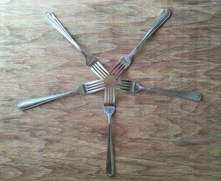
Looking at the objects you classified as different, consider how many orders of rotational symmetry they have. Remember that if a shape only fits into itself once, it has no rotational symmetry. This rectangular block has two orders of rotational symmetry:

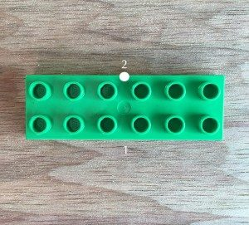

Titanic

The Challenge
Build a boat and test how much weight it can carry.
- Gather your construction team. You may want to involve a parent, grandparent, brother or sister, or family friend.
- Collect the following: a ruler/tape measure; materials to build your boat (e.g. sticks, wood, empty bottles or corks – you can use just about anything that will float and not get soggy); and some sticky tape, string or glue to stick your boat parts together.
- Clear some space and use your team skills to build the best boat you can in 30 minutes – it should be no bigger than 30cm long by 15 cm wide by 10 cm tall.
- Collect some objects you can use as known weights to put in your boat to test how much weight it can take (e.g. coins, some metal spoons or a tin of tomatoes).
- Each team member should estimate how much weight they think the boat can hold and guess whether the boat will (a) sink or (b) capsize. Write down everyone’s estimation before you test your boat.
- Find somewhere to test your boat (e.g. a sink, bucket, bathtub or esky). Add weights and test how much weight your boat can carry before it sinks or tips over (capsizes). Remember, not too heavy to start with!
- Capture images or video of your boat.
- Reflect: what was the maximum amount of weight your boat managed to hold before sinking or capsizing? Discuss whether a different shape could have worked better, then try it out!

Materials
- a device to view the challenge and submit entries
- ruler/tape measure
- materials to build your boat (e.g. sticks, wood, empty bottles or corks)
- sticky tape, string or glue

Prompting Questions
- What shapes do you see boats made from?
- What makes boats float well?
- Think about how deep you will make the boat, the surface area it will cover on the water. Will it be better to be smaller and go deeper or cover more area and stay shallow?
- How will you distribute the weight in the boat?
- Will you make compartments or have it all open?
- Think about what materials around your home float more easily.
- Can you work out the amount of water displaced by your boat? Can you measure the mass of your boat? Can you work out a relationship between mass of the boat and water displaced?

Keep going for an extra challenge
Grab five to ten items from around the house and get family members to guess which ones will float and which ones will sink. Write down the guesses and see who guesses the most items correctly. Remember to only use waterproof items or items that won’t be affected by getting wet. Some suggestions for items to test:
- Fruits: apples, bananas, mandarins, oranges
- From outside: Sticks, leaves, rocks
- Assorted household items: waterproof keys, coins, forks and spoons, pots
What makes a good estimate? Having a good idea from past experience helps you to make good estimates. The more you experiment and the more data you obtain about the world around you, the better educated your guesses become.

Traveller

The Challenge
Find the shortest route a traveler could take.
- Split into teams. You may like to work by yourself or pair up with another person.
- Print a copy of this worksheet for each team member. If you don’t have access to a printer you can draw your own copy.
- Moving from point A, visit every red dot and return to Point A.
- Count your total travel distance. Each two dots you travel between counts as 1.
- Try more combinations. See if you can get your total distance as low as possible.
- After 10 minutes, see which team has the smallest total travel time.
- Discuss how you worked through the problem.

Materials
- a device to view the challenge and submit entries
- copies of Traveller Challenge template for each person
- copies of Traveller Keep Going Challenge
- pens / pencils

Prompting Questions
- How can you find the shortest route possible? What strategies could you use?
- Would it be better to go direct or take different routes?
- What type of lines would be most efficient, horizontal or vertical?
- Would it be better to travel to each spot only once or revisit if needed?
- Remember to write down the letters of the paths you draw. How many points can you join up without crossing over a connecting line already drawn?
- When connecting all the dots, do you have to pass through any dot more than once?

TRAVELLER CHALLENGE
INSTRUCTIONS + MAP
Starting from point A, find the shortest route you can that passes through every red dot and returns to point A again. You can only travel vertically and horizontally between dots. You are allowed to travel between the same two dots more than once.
Count the total length of your journey by counting the number of times you joined a pair of dots remembering to include extra length if you travelled between the same dots more than once.
Remember to try plenty of combinations. There are 14 red dots you need to travel between, which means even if you always take the most direct routes between red dots there are over 3 billion possible answers.
N
M
L
K
J
I
H
G
F
E
D
C
A
B

Keep going for an extra challenge
Find the best place to place a hardware store.
- Split into teams. You might like to change teams at this point.
- Print a copy of the traveling salesman keep going for an extra challenge sheet for each team. If you don’t have access to a printer you can draw your own copy.
- Decide where the best place for a hardware store might be to minimise travel distance.
- Count your total travel distance for a person in each location to travel one way to the hardware store. Each two dots you travel between counts as 1.
- Try more combinations. See if you can get your total distance as low as possible.
- After 10 minutes, see which team has the smallest total travel time.
- Discuss how you worked through the problem

TRAVELLER KEEP GOING
INSTRUCTIONS + MAP
Choose a single dot on the map to hold a hardware store. Each red dot on the map represents a house. Try to make the distance between the hardware store and the other houses as small as possible.
You can only travel vertically and horizontally between dots. You are allowed to travel between the same two dots more than once.
Find the distance between each house and the hardware store and then add all of those distances together to find the total distance.
Remember to try plenty of combinations.
N
M
L
K
J
I
H
G
F
E
D
C
A
B

See, for example: Maloney, E. A., Ramirez, G., Gunderson, E. A., Levine, S. C., & Beilock, S. L. (2015). Intergenerational Effects of Parents’ Math Anxiety on Children’s Math Achievement and Anxiety. Psychological Science, 26(9), 1480–1488.

